**Jobsheet-5: Login multi-user dan logout**

**Mata Kuliah Pemrograman Web Lanjut**



**Oleh :**

**MUHAMMAD AQSAL ZILDJIAN / NIM : 1841720191**

**KELAS TI 2A**

**PROGRAM STUDI TEKNIK INFORMATIKA JURUSAN TEKNOLOGI INFORMASI POLITEKNIK NEGERI MALANG**

**2020**

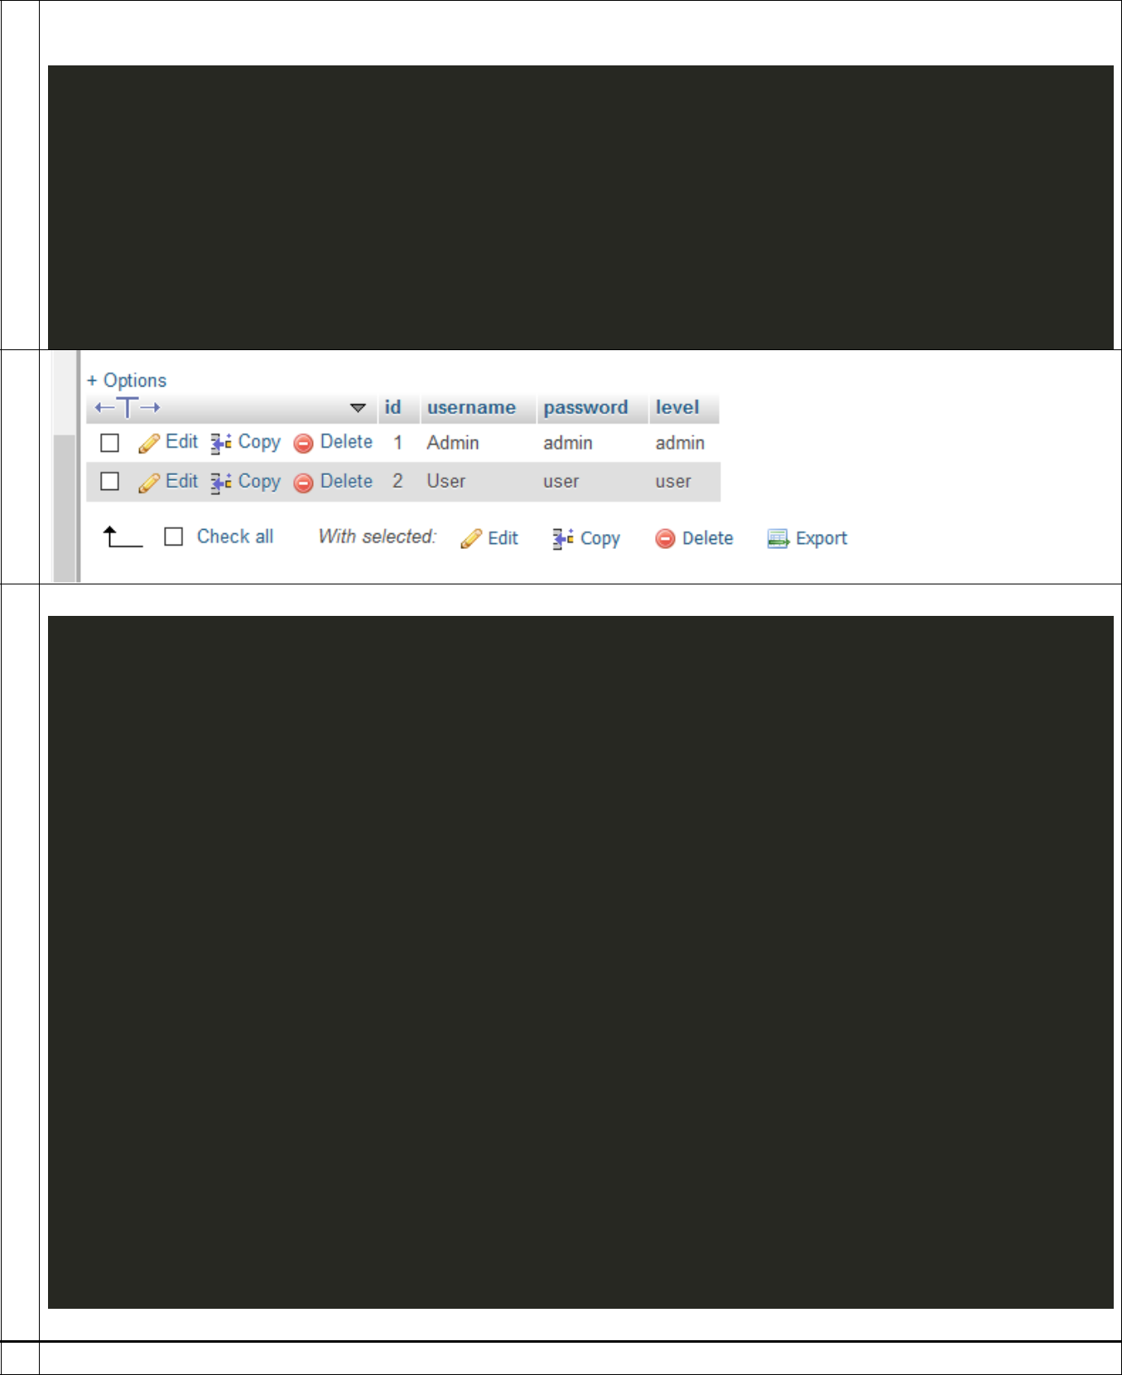

1. Login.php

.

<?php

*class* loginextends *CI_Controller*{

public *function* index(){

$data['tittle'] = 'Login';

$this->load->view['template/header_login',$data];

$this->load->view['login/index'];

$this->load->view['template/footer'];

}

}

2

3 Model login_user

<?Php

*function* login($username, $password){

//var_dump($username);

//var_dump($password);

$this->db->select('username,password,level');

$this->db->from('user');

$this->db->where('username', $username);

$this->db->where('password', $password);

$this->db->limit(1);//artinya data yang diambil hanya satu/1

$query=$this->db->get();

if($query->num_rows()==1)//jika data ditemukan

{

return $query->result();

}else{

return false;

}

}

?>

4 Ubah config/routes

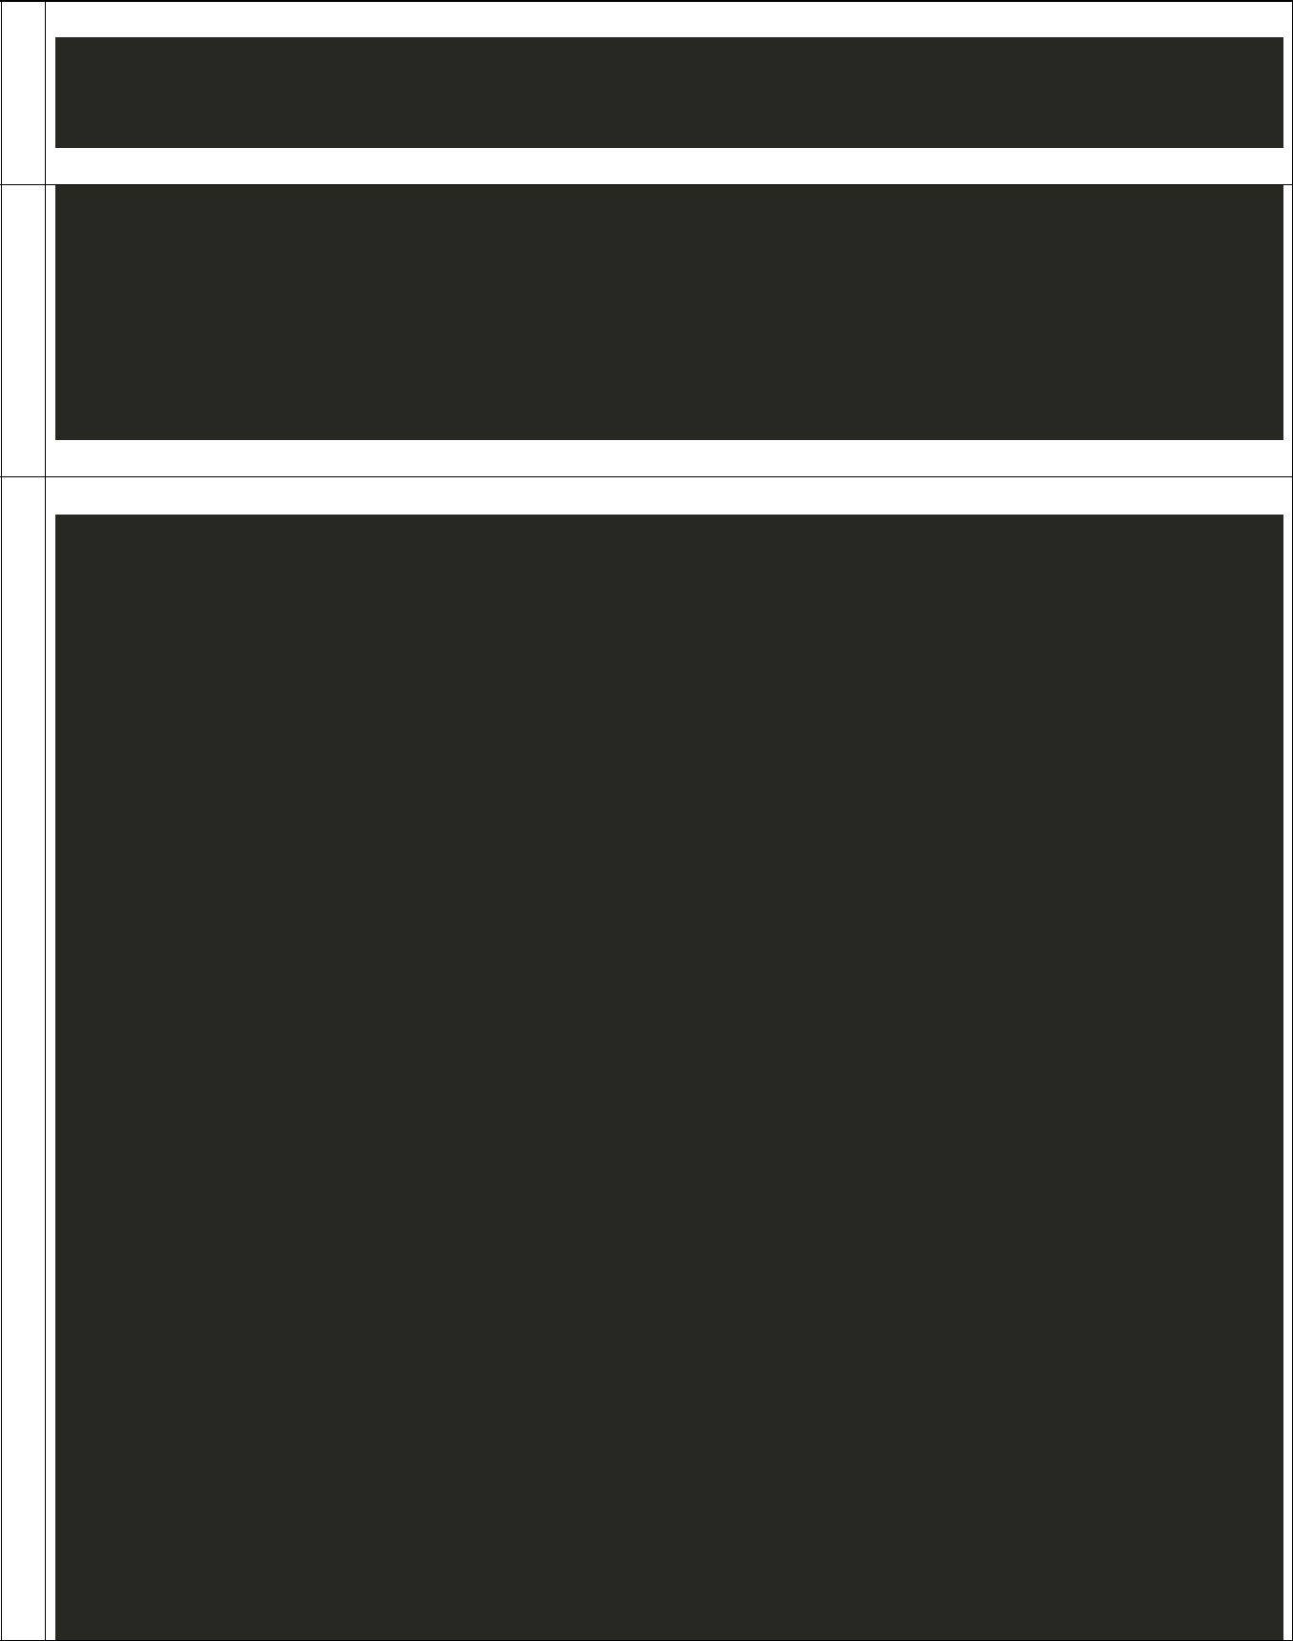

$route['default_controller'] = 'login';//rubah menjadi login yang sebelumnya adalah

home

$route['404_override'] = '';

$route['translate_uri_dashes'] = FALSE;

1. }

elseif($this->sessions->userdata('level')=="user"){

redirect('mahasiswa/user');

}

}

6 Views>login.php

<?=

form_open('login/proses_login');

?>

<div class = "container py-5">

<div class="row">

<div class="col-md-12">

<div class="row">

<div class="col-ad-6 mx-auto">

<!-- form card login -->

<div class="card rounded-0">

<div class="card-header">

<h3 class="mb-0">Login</h3>

</div>

<div class = "card-body">

<form class = "form" role="form" autocomplete = "off" id="formLogin

* novalidate="" method="POST">

<div class="form-group">

<label for="uname1">Username</label>

<input type="text" class="form-control form-control-lg rounded-1" name="uname1" id="uname1"

required="">

<div class="invalid-

feedback">Oof, you missed this one.</div>

</div>

<div class="form-group">

<label>Password</label>

<input type="password" class="form-control form-control-lg rounded-0" name="pwd1" id="pwd1"

required="" autocomplete="new-passwords">

<div class="invalid-feedback">Enter your password too!</div>

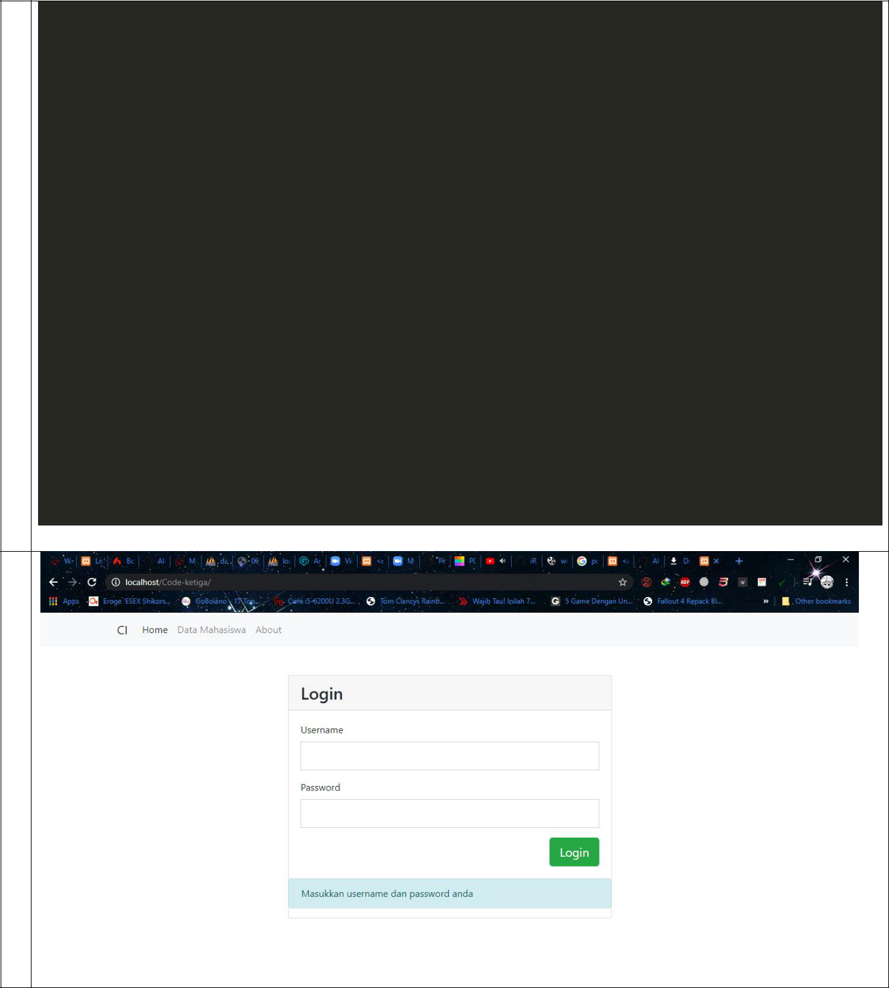

</div>

<button type="submit" class="btn btn-success btn-lg float-right" id="btnLogin">Login</button>

</form>

</div>

<!--/card blok -->

</div>

<!--/from card login -->

</div>

</div>

<!--/row -->

</div>

<!--/col -->

</div>

<!--/row -->

</div>

<!--/container -->

<?=

form_close();

?>

7

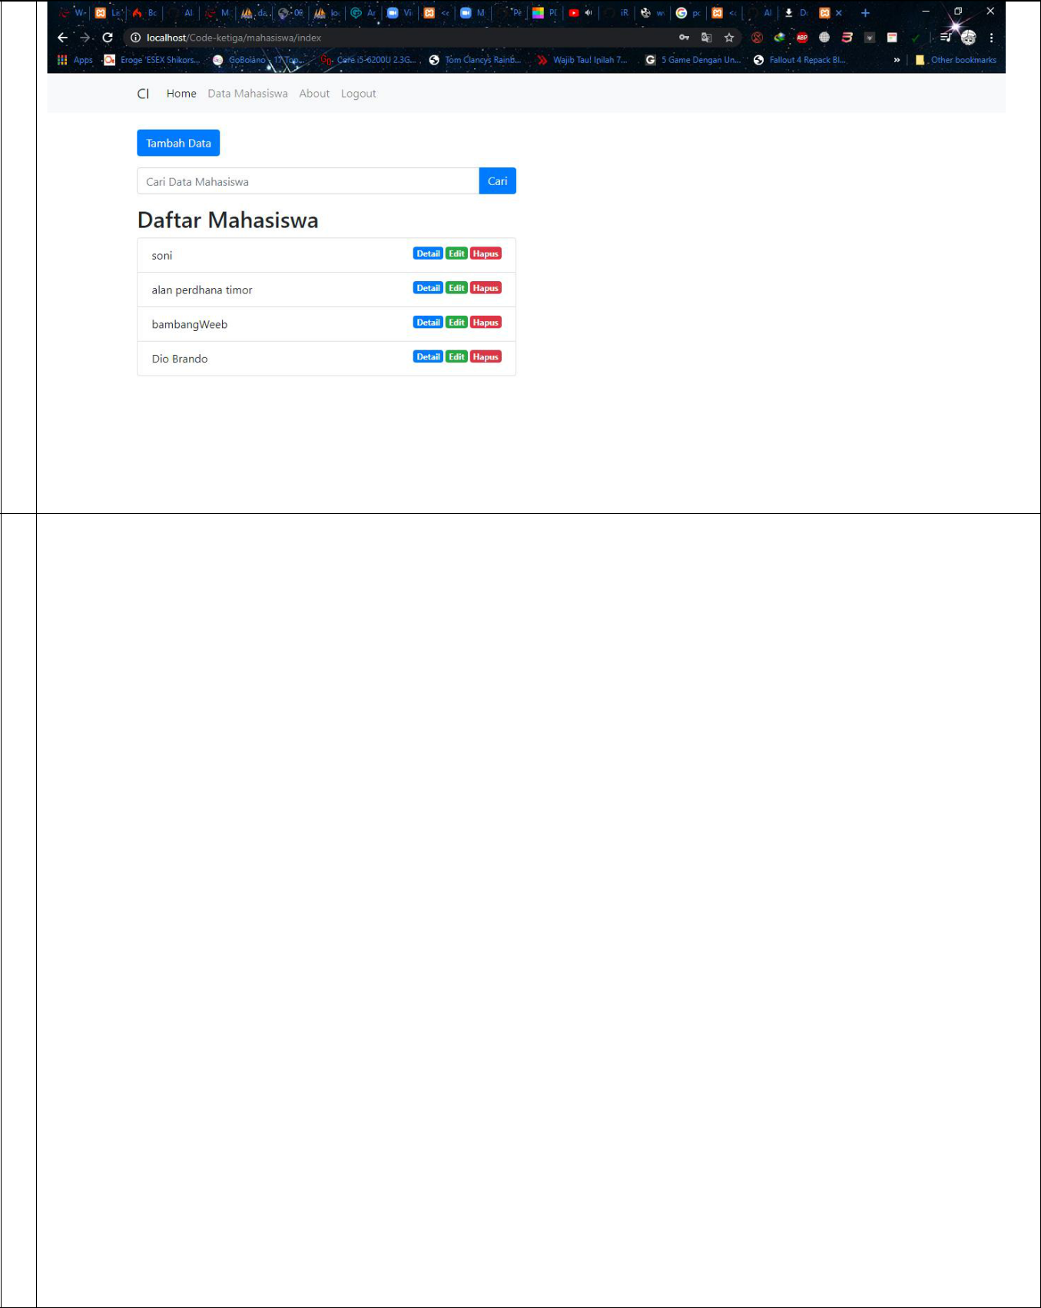

8

9 Membuat controler user di contrler > user

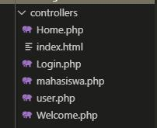

|  |  |  |  |  |  |  |
| --- | --- | --- | --- | --- | --- | --- |
|  | <?php | | | | |  |
|  | defined('BASEPATH') OR exit('No direct script access allowed'); | | | | |  |
|  | *class* userextends *CI_Controller* { | | | | |  |
|  |  |  |  |  |  |  |
|  | public *function* index() | | | | |  |
|  | { |  |  |  |  |  |
|  | $this->load->view('mahasiswa/user') | | | | |  |
|  |  |  |  |  |  |  |
| 1 | Membuat view user di view > user | | | | |  |
| 0 |  |
|  |  |  |  |  |  |

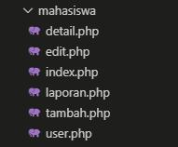

|  |  |  |  |
| --- | --- | --- | --- |
|  |  | <h1> ini halaman user </h1> |  |
|  |  |  |  |
| 1 |  | Tambahkan menu logout di view/template/header |  |
| 1 |  |  |
|  |  | <div class="navbar-nav"> |  |
|  |  | <a class="nav-item nav- |  |
|  |  | link active" href="<?= base_url(); ?>">Home <span class="sr- |  |
|  |  | only">(current)</span></a> |  |
|  |  | <a class="nav-item nav- |  |
|  |  | link" href="<?= base_url(); ?>mahasiswa">Data Mahasiswa</a> |  |
|  |  | <a class="nav-item nav-link" href="<?= base_url(); ?>">About</a> |  |
|  |  | <a class="nav-item nav- |  |
|  |  | link" href="<?= base_url(); ?>login/logout">Logout</a></a> |  |
|  |  | <!--<a class="nav-item nav-link disabled" href="#">Disabled</a>--> |  |
|  |  | </div> |  |
|  |  |  |  |
| 1 |  | Tambahkan function logout di controller login. |  |
| 2 |  |  |
|  |  |  |  |
|  |  | public *function* logout() { |  |
|  |  | $this->session->sess_destroy(); |  |
|  |  | redirect('login', 'refresh'); |  |
|  |  | } |  |
|  |  | } |  |
|  |  |  |  |

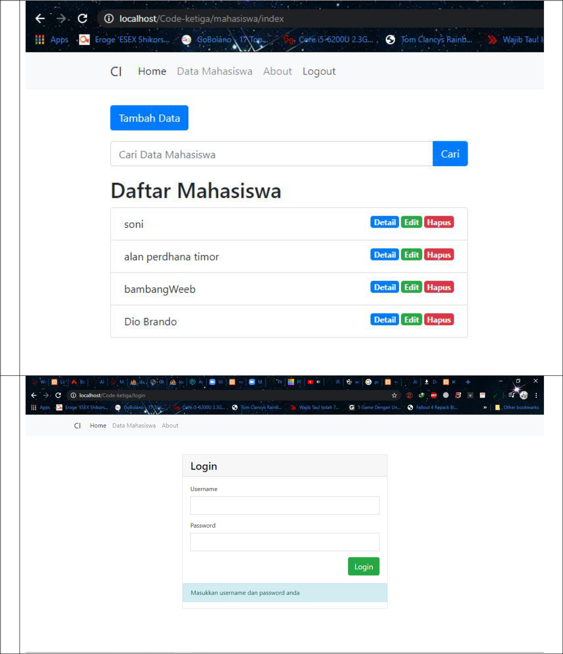

1

3

1

4